|  |  |  |
| --- | --- | --- |
|  | **JSS Mahavidyapeetha**  **JSS Academy of Technical Education, Noida Department of Electronics and Communication Engineering**. |  |

**Mini Project Short Report**

1. **Project Title:** Sun Tracking Solar Panel
2. **Group No. :** 6
3. **Section:** ECE-3
4. **Group Member’s Name and Roll No. :**

Sahil Khan 2100910310118

Sambhav Saxena 2100910310121

Vardaan Sharma 2100910310168

Vipul Jain 2100910310171

1. **Mentor/Coordinator Name:**

Pooja Pandey Mam

Rakesh Kumar Sir

1. **Project Description:**

We have designed the prototype of the Sun-Tracking Solar Panel using Arduino UNO. In this Prototype, we are using the LDR (Light Dependent Resistor) sensor to detect the sunlight intensity and servo motor for automatic rotation of the panel using the Arduino.

The solar panel uses photovoltaic cells (PV cells). The PV cells detect the light intensity and according to that, the tracker adjusts the direction that a solar panel to the position of the Sun in the sky. Every time, the tracker adjusts the panel perpendicular to the Sun so more sunlight strikes the solar panel, less light is reflected. Hence, it absorbs more energy which can be converted into power.

The intensity of light is measured with **LDRs** using Arduinoand compared the intensity of light falling on both LDRs. The LDRs are placed on the edges of the solar panel. Based on the intensity of light on the LDR, we give the signal to the servo motor to cause the movement. When the intensity of the light falling on the right LDR is more, the panel turns towards the right and if the intensity is higher on the left then the panel slowly turns towards the left side.

1. **Implementation Cost (in Rs):**
   1. Arduino UNO 750
   2. Servo Motor 150
   3. Solar Panel 60
   4. LDR & Resistors 60
   5. Breadboard 30
   6. Jumper Wires 50
2. **Project Photograph of Working Model:**

* Components Required=

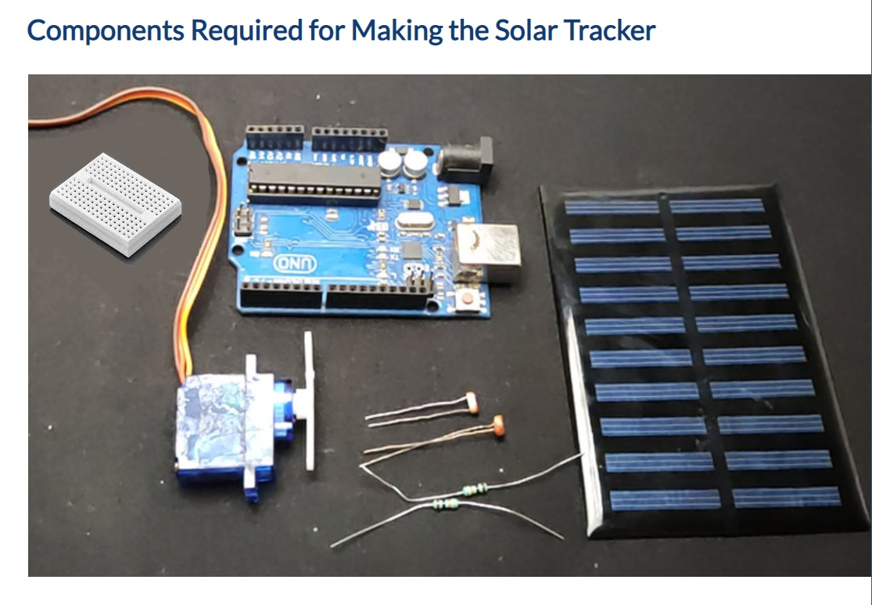

* Circuit Diagram=

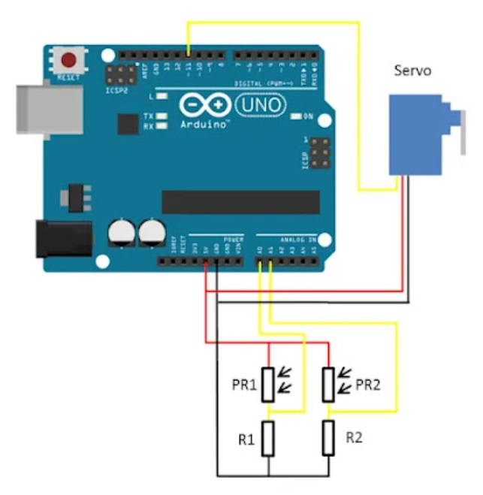

* Normal Position=

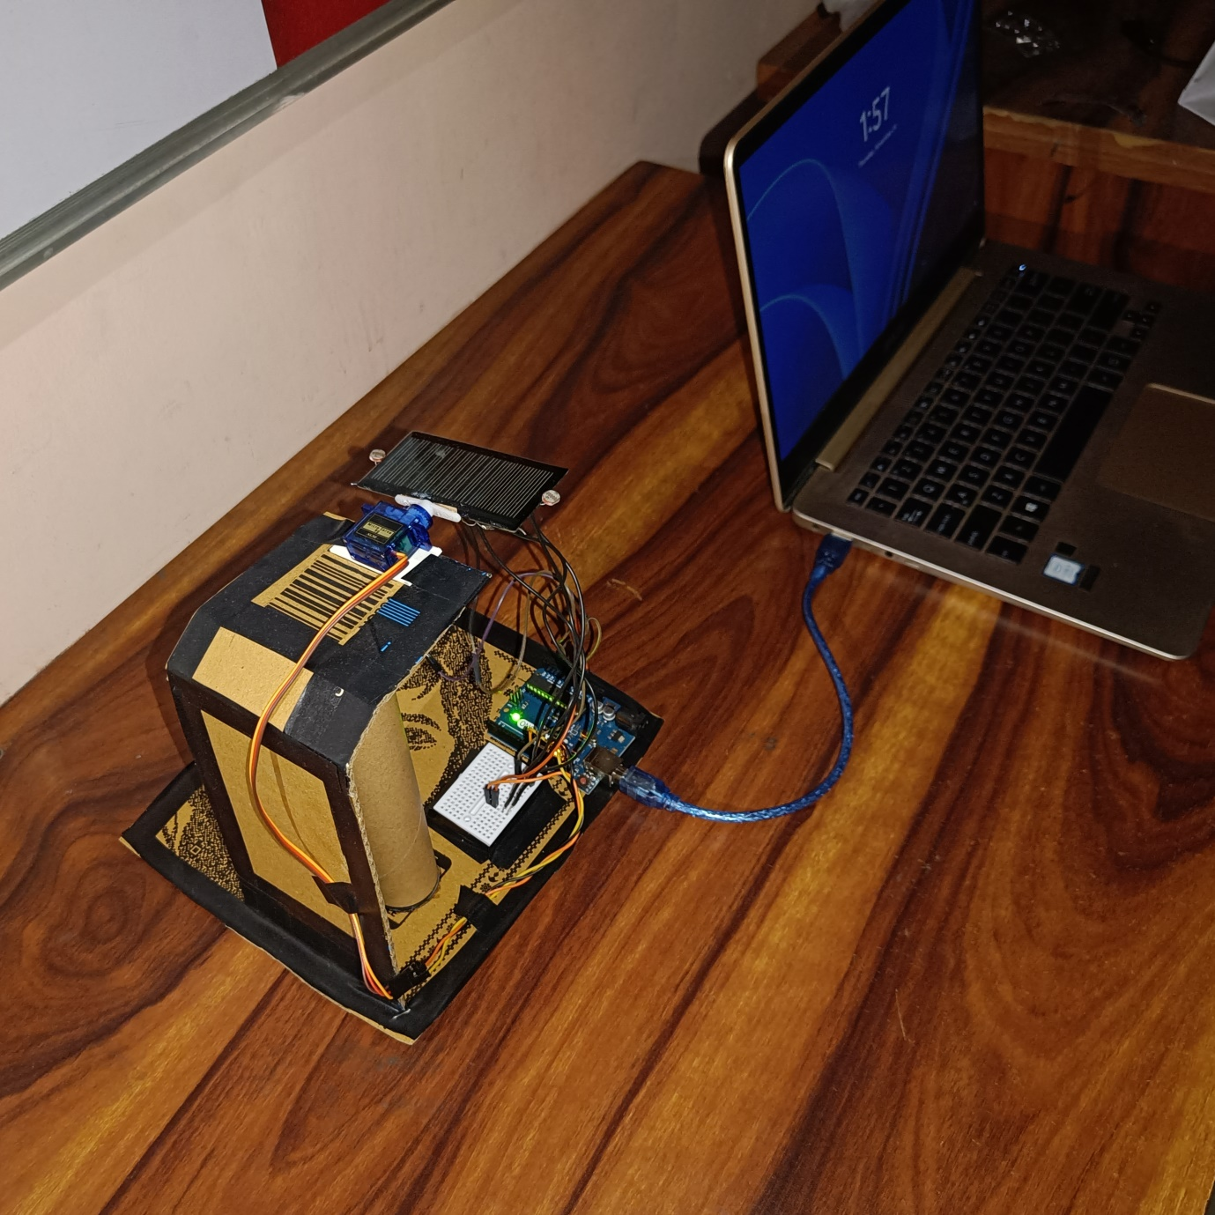

* Right Side Inclined=

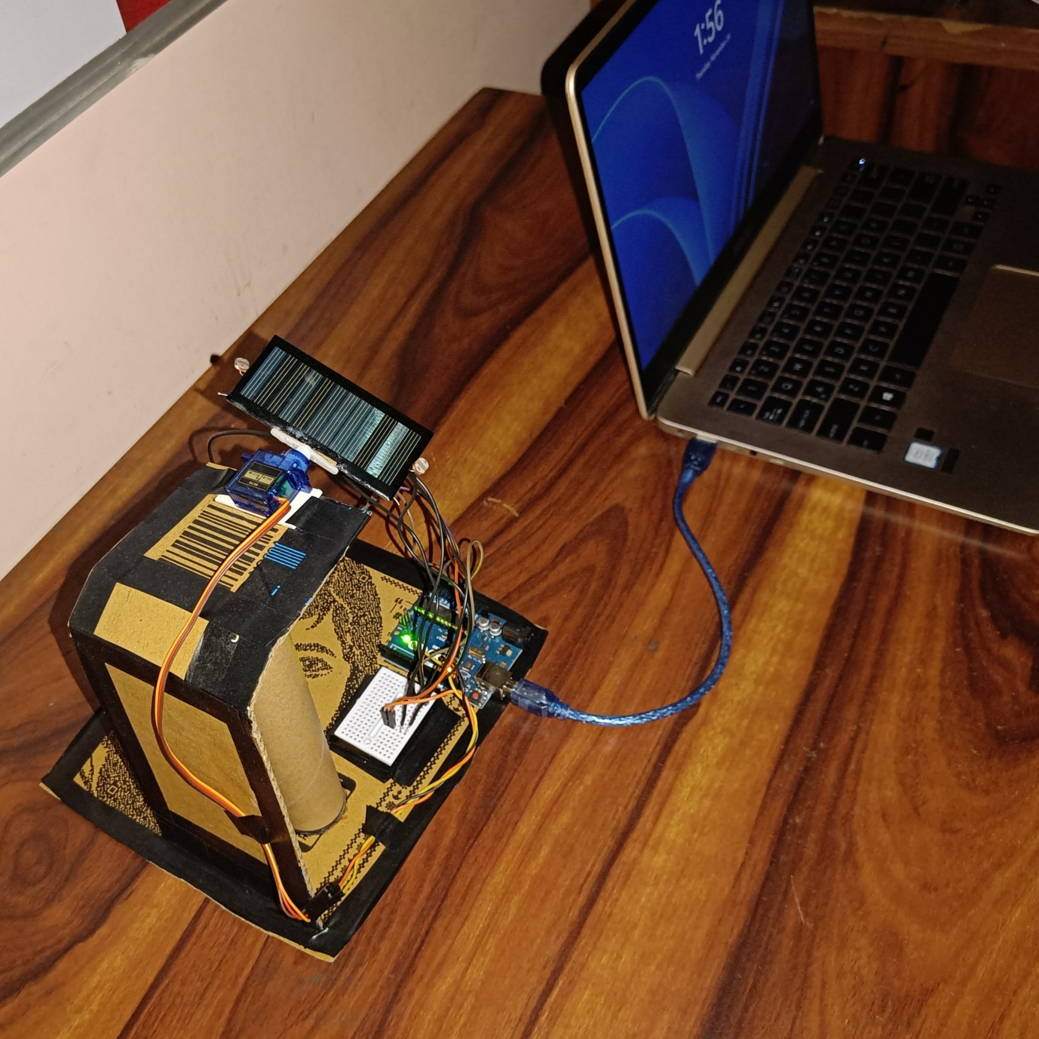

* Left Side Inclined=

